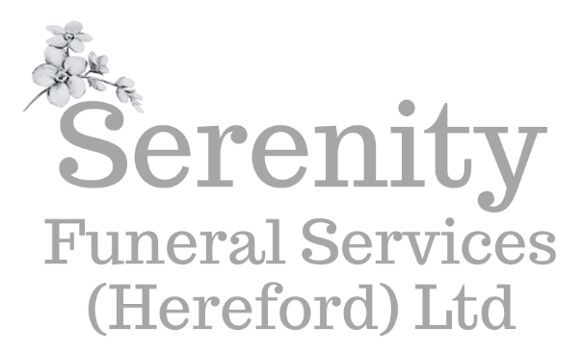

Additional Options Price List
Ashes Caskets | From £80.00
Solid Oak Coffins | From £1,320
Scatter tubes | Medium: £35.00 Large: £50.00
Bespoke ashes keepsake items | From £10.00 each
Embalming | From £195.00
Shrouds/Gowns | From £60.00
Additional mileage over 15 mile radius | £1.85 per mile
Transfer of coffin (home or a place of worship) | From £220.00
Saturday funeral surcharge: | £285.00
Saturday funeral vehicle surcharge: | £80.00 per vehicle
Floral tributes | 3ft double-ended coffin spray from £160.00  4ft double-ended coffin spray from £195.00  5ft double-ended coffin spray from £225.00  6ft double-ended coffin spray from £260.00  Bespoke novelty floral tributes - prices available from our brochure
Additional bearers (if required) | £80.00 each
Silver fingerprint Jewellery | Prices on request
Bespoke memory bears | Prices on request from third party supplier

